MacCarthaigh, Libby

Week 2

Assignment 2 – Debugging

Breakpoint added, debugging triggered

Step Into

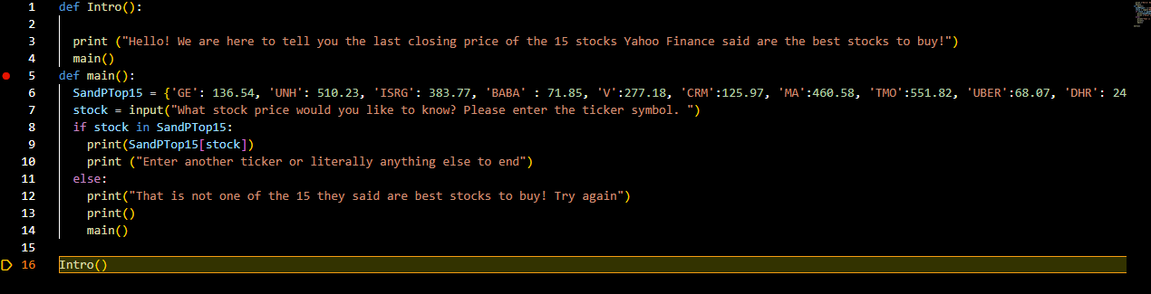

Started debugging over and used Step Over after the breakpoint

